Gastroenterology / IBD
Cross-site

Diagnosing and treating irritable bowel syndrome (IBS)

What is irritable bowel syndrome (IBS)?
IBS is a series of related conditions linked by bowel / gut symptoms without any visible gut damage or disease, such as ulcers, bleeding, soreness and growths.
The symptoms vary according to which area of the bowel is most affected, although some people can have symptoms from multiple segments of the bowel.
The irritable bowel syndromes share the same characteristics: normal results from investigations of the gut, stool tests, camera tests and X ray tests. However, despite the normal test results, the way the gut works (the gut function), can be very impaired, e.g., slow bowels, faster bowels, nausea. This is why IBS conditions are also called ‘functional bowel disorders’.

Upper gut (gullet and stomach) IBS
This can result in a spasm of the throat muscles affecting swallowing; and pain in the chest that doesn’t improve with anti-acid treatment.
Stomach symptoms include nausea and pain, which again don’t always improve with anti-acid treatments.

Lower gut (intestine and colon) IBS
This can result in altered bowels (diarrhoea, constipation or a mixture of both), swelling (bloating) and colicky pain.
Bloating is always variable and can increase during the day, and especially after meals.
The pain of intestinal IBS comes from muscle spasm and can be very severe: some patients even attend A&E with pain from an area of bowel spasm.
Some basic facts about IBS
IBS is very common, affecting up to 20% of the population in some surveys. It tends to affect women more than men and younger patients more than older ones.
As it is so common, it often affects family members. No obvious genetic factors have been found for the majority of cases.
The causes of IBS result in alterations to the deeper layers of the bowel and therefore can’t be seen on standard tests. These layers contain the gut nerves and muscles and control how the gut moves food through and the pain sensations felt in the bowel.
Other gastroenterological conditions that can mimic IBS, such as inflammatory bowel disease, coeliac disease and, in rare cases, cancers, all affect the surface (skin) layer of the bowel and can be picked up by testing bowel contents (faecal tests), blood tests and by looking at the bowel with a camera.
IBS can’t be detected by faecal tests, blood tests or cameras, it’s more than skin deep. This can be very frustrating for patients who are suffering with severe symptoms such as pain or bad diarrhoea, who are told that ‘your test results are all normal’.

The causes of IBS
- Infections
These are a very common trigger for IBS. They can be obvious, e.g., gastroenteritis; or not noticed (some viral infections). The infections are thought to affect the immune cells in the gut leading to increased sensitivity to certain foods and events e.g., major life events, other stresses.
- Change of diet and food intolerances
This can result in a change to the bacteria in the bowel, which can result in more gas production, leading to bloating and bowel alteration. In addition, many foods are not easily digested e.g., milk if a patient has lactose intolerance, or insoluble fibres (bran, shredded wheat, etc).
- Recent antibiotics
These can also change the gut bacteria and result in a change in bowel habit and changed tolerances to certain foods.
- Role of stress and anxiety
It is very well known that stress and anxiety worsen IBS and that patients with IBS score significantly higher on mental health disease activity scores than those without IBS.
This is not at all surprising as IBS results from nerve dysfunction in the bowel. The bowel has millions of nerves in it; so many that some call the gut the second brain.
We are all used to experiencing temporary gut symptoms during periods of high stress, e.g., diarrhoea before a big exam or a driving test. Some patients with IBS seem to be ‘stuck’ with a situation of permanent high gut nerve activity and sensitivity.
This can be demonstrated in experiments conducted on patients with IBS, e.g., the rectal balloon experiment. Patients with and without IBS had a balloon placed inside their lower bowel and this balloon was inflated. Patients with IBS were able to feel and notice the balloon when it was significantly smaller than those without IBS, showing that their bowels were much more sensitive.
These bowels were not inflamed, damaged, bleeding or ulcerated, the tests on the bowel contents were all normal but the bowels felt as if they were inflamed, ulcerated and sore.

What tests should be done before IBS is diagnosed?
An article in a national newspaper in 2015 featured a number of patients whose conditions had not been diagnosed correctly because their GPs had not requested the standard tests which would have indicated whether or not they had IBS. We will now explain what tests can be carried out to narrow down the possibility of IBS being the cause of the patient’s symptoms, as opposed to other conditions causing similar discomfort or changes in bowel behaviour.

Conditions which mimic IBS and the tests needed to exclude them
  - Inflammatory bowel disease (IBD) - ulcerative colitis and Crohn’s disease
These patients go to their GP with altered bowel habits and pain. There is a family history of IBD in 10% of these cases. In addition to bowel symptoms, patients can have chronic mouth ulceration and weight loss.
Tests for IBD include:
1) Blood tests to rule out anaemia (full blood count) and inflammation (CRP level).
2) Faecal tests of inflammation: the calprotectin test. This usually registers a level above 250 in cases of IBD; and if the reading is under 50 in a patient under 50 years old, it means that there is a 99% plus chance of IBS and not IBD.
In cases where the calprotectin is over 50 but under 250, this might represent a recent bowel infection or reaction to a food or drug and the GP is advised to repeat it to see if it goes down.
2) Bowel Cancer
This is uncommon but not unheard of in younger patients. Constant pain and bloating can be a feature, as obviously is weight loss. These are uncommon symptoms in IBS.
The calprotectin test can be very raised in bowel cancer. In addition, the GP might choose to test the stools for hidden bleeding with a new test called the FIT test, which is used as a standard test to screen for bowel polyps and cancer in the over-60 age group. Blood tests will reveal anaemia from internal bleeding.
3) Coeliac Disease
This is a common condition, affecting 1% of the population, and results from an immune reaction to gluten, the protein found in wheat, rye and barley. It is found in 5-10% of patients who visit their GP with suspected IBS, with an increased risk of 10% in those with a parent/child or brother/sister already diagnosed with coeliac disease.
The symptoms can be very variable but include changed bowel habits, bloating, pain and lethargy. Some people also experience weight loss, nausea, hair loss, headaches, mouth ulcers and tingling and numbness in their hands and feet.
Fortunately, there is a very sensitive blood test for coeliac disease, the TTG antibody test, which is over 95% accurate.
- Ovarian Cancer
In cases of chronic bloating, GPs are advised to arrange an ultrasound scan and a blood test aimed to detect ovarian cancer. This is, fortunately, very rare and we have never seen a missed case in our Gastroenterology clinics here at Frimley Health.
- Endometriosis
This condition can be very painful, but less commonly affects the bowel habit and does not cause much bloating. Clues are severe worsening during periods

Managing my IBS
Firstly, it’s vital to make a positive diagnosis as quickly as possible to ensure other conditions are excluded and to allow early treatment.

Dietary Treatment
Many patients know that diet affects their symptoms. There is no ‘one size fits all’ diet, as everyone is different, with different groups of bacteria inside their bowels. These differences are reflected in their reactions to food.
NICE have provided some very helpful advice on their website in conjunction with the British Dietetic Association for example on food items to be voided for 6-8 weeks.

Fodmap is a diet to reduce fermentable carbohydrates

Our dietitians at Frimley Park have created an IBS Webinar which goes through the first line advice for IBS. If, after following this advice, symptoms have not resolved, details are provided that allow patients to self refer to dietitians for advice on the Low Fodmap diet. This is a diet which is followed for 6-8 weeks and restricts certain foods which contain fermentable carbohydrates. If symptoms improve after the initial restriction period, it is important to re-introduce foods to identify which carbohydrates you are able to tolerate. If you would like to watch the IBS Webinar, please email fhft.ibswebinar@nhs.uk.

Prebiotic and Probiotic ‘bacterial treatments’
Everyone has a different population of bacteria inside their bowels, so their reaction to taking probiotics (live ‘good’ bacteria) and prebiotics (foods that encourage the growth of the ‘good’ bacteria) will vary.
For this reason, the trials of using pre- and probiotics in IBS have had mixed results. Some patients get better, others don’t and some might get worse. Prebiotic fibre has a high content of fermentable carbohydrates and could increase bloating.
However, these treatments are very safe and easy to access and we would recommend a 2-4 week trial of a well known liquid probiotic to see if it helps, e.g., Yakult or Actimel, both of which are available from supermarkets.
If you are avoiding dairy, then we would recommend ‘Symprove’ (available on-line) or fermented Kombucha (available in supermarkets).
These all contain high numbers of the good bacteria (lactic acid bacteria that are seen in live yoghurt such as lactobacilli and bifidobacteria).

Psychological interventions: Talking therapies
These have proven benefit in IBS, working by reducing the gut nerve sensitivity and symptoms.
Many patients find using a relaxation or meditation App such as ‘Headspace’ very helpful.
There are some hypnotherapists with experience in treating IBS but, unfortunately, the treatment is rarely available on the NHS.
Those with more severe anxiety/stress/depression scores can really benefit from Cognitive Behavioural Therapy (CBT).
CBT is now available in the community via a variety of providers.
If your GP is in Yateley, Fleet, Farnborough, Blackwater, Aldershot or Farnham you can self refer via:
https://www.talkplus.org.uk/ 01252 533355
If your GP is in Berkshire, you can self refer via:
https://www.talkingtherapies.berkshire.nhs.uk/ 0300 365 2000
If your GP is in Surrey, you can self refer to
www.iesohealth.com 01954 230066

Drug treatments
1) Anti-spasm drugs
These help the cramps by relaxing the bowel muscles. Examples available over the counter include Buscopan , Spasmonal and Colpermin. They are safe and can be taken as and when needed for cramps or regularly, with meals for more chronic symptoms
2) Bulking laxatives
These help alleviate constipation by drawing water into the bowel. They shouldn’t increase bloating and gas production as they don’t get digested by the gut bacteria: they work by physically bulking the gut contents. They are available over the counter as Fybogel and methylcellulose (‘Celevac’).
3) Osmotic Laxatives
These are salty powders that draw water into the bowel by osmosis and do not produce a bulking effect. They are also extremely safe and are the preferred laxatives for babies and children for this reason.
Osmotic laxatives are available over the counter: ask for Movicol or Laxido.
4) Anti-diarrhoeal drugs
Our drug of choice is loperamide, which is available over the counter. It slows the bowels by acting on the opiate receptor and is extremely safe.
Although used by many as a short term treatment for infective diarrhoea, we recommend its use for chronic symptoms as it is so safe and well tolerated. The only common side effect is constipation.

5) Drugs that affect the gut nerves
There are a number of medicines that will affect gut nerve function and improve the symptoms of IBS. They are especially good for pain as they work directly on the nerves. As the gut nerves use the same chemicals to transmit messages as the brain nerves, these treatments are often very low doses of known anti-depressants.
One of the most well known and most commonly used is amitryptiline. It is rarely used now to treat depression due to side effects at the doses needed to help mood, although it is still one of the most effective anti-depressants. In very low doses (10mg-30mg) it can be very effective in IBS and is usually our first choice of medication for more severe cases, or for those in whom diet and psychological treatments are not 100% effective.
There are alternatives for those who don’t tolerate amitryptiline such as low dose citalopram and paroxetine. These drugs are available on prescription only and can be supplied by a GP.

Can I combine treatments?
Absolutely.
Many of our most severely affected patients are on combination treatment. They are on a careful diet, taking an anti-spasm drug or amitryptiline and have interacted with psychological therapies as well.
The treatments are complementary, not exclusive, although we don’t usually recommend starting all types of treatment at once as it might be hard to work out which are helping the most.

Summary
We really hope that this information has been helpful to you.
By helping patients with IBS to help themselves, we can reduce the number of patients waiting months for an appointment and get them started on their treatment much earlier.
We are keen to speed up referrals to our Gastroenterology clinics, so we ask local GPs to request all the correct tests to rule out IBD, coeliac disease, etc. We assess all GP referrals by ensuring they have checked stools, bloods, etc.
We do appreciate that some patients find it very valuable and reassuring to see a specialist. In some cases of severe anxiety and depression, we can refer a patient to a Clinical Psychologist.

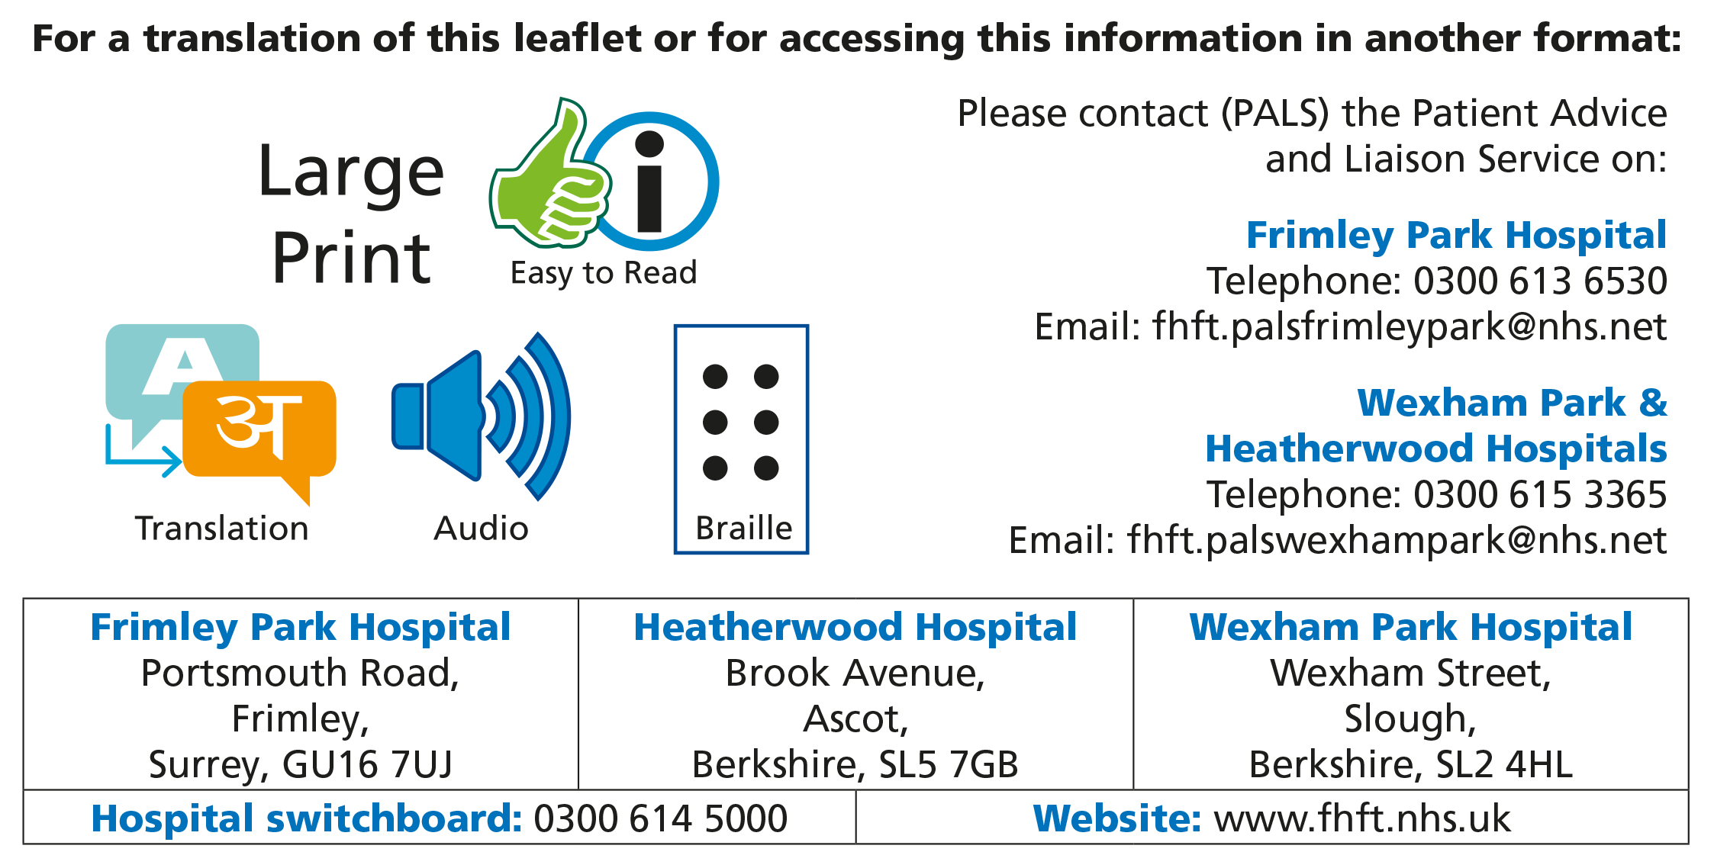

Title of Leaflet | Diagnosing and treating irritable bowel syndrome (IBS)
Author | GI Consultants |  | Department | Gastroenteorology
Ref. No | H/070/2 | Issue Date | April 2023 | Review Date | March 2026

Legal Notice
Please remember that this leaflet is intended as general information only. We aim to make the information as up to date and accurate as possible. Please therefore always check specific advice or any concerns you may have with your doctor.

