Lumbar spine x-rays from primary care

As described in our previous communication, routine x-ray imaging of the lumbar spine for the assessment of underlying causes of non-specific low back pain is not recommended; it is usually of little diagnostic benefit (in identifying symptomatic degenerative changes or causes of radicular pain) and rarely guides further management. In addition, spinal x-rays are a high radiation dose procedure (one lumbar spine x-ray equates to approximately 75 chest x-rays from a radiation perspective) and could lead to patient harm.

Frimley Health Radiology Department do not recommend routine lumbar spinal x-rays for patients under 50 years old. The following three indications below have been permitted, however please be advised that a lumbar X-Ray even in these situations is likely to represent suboptimal imaging and may falsely reassure:

- History of trauma, or
- Past/current history of cancer, or
- Sudden onset of back pain in someone with suspected or known osteoporosis

We are pleased to confirm as of 21.07.2021, ICE has been updated to make this referral process and criteria clearer. Please see ICE screen shots below.

Any referrals that do not meet the criteria will be returned with an explanation written on the ICE report which will be flagged by email to the GPs generic inbox with the subject heading ‘Returned Lumbar X-Ray Request’ (please see Appendix 1). The patient will also be given a patient leaflet explaining the reasons as to why we were unable to undertake their x-ray (please see Appendix 2).

Further Information:
Please refer to the NICE guidance on Low Back Pain NICE guidance NG 59 Dec 2020 https://www.nice.org.uk/guidance/ng59 which supports the above criteria. Please refer to the local ICS-wide MSK pathway for further management recommendations. This is available on DXS Frimley Health and Care Folder ‘Orthopaedic MSK’ Landing page by selecting the spinal body part (see screen shot below).

For further support, please contact the Radiology team using the contact details below. These can also be found on the DXS Homepage and within the FHFT GP Centre: https://www.fhft.nhs.uk/gps/gp-centre/urgent-advice/

- Frimley Park: Mon-Fri 9.00-5.00, Telephone: 01252 649680
- Heatherwood & Wexham Park: Mon-Fri – 9.00-5.00, Email: fhft.radiology.secretarieshwph@nhs.net

Appendix 1 - GP Notification via E-mail (North) or Letter (South) – Returned Lumbar Spine X-Ray Request
Any request for lumbar spine x-ray will be returned to primary care with the following notification:
Subject Heading: Returned Lumbar X-Ray Request’ (see ICE report for further details)

We have recently received a request for a lumbar spine x-ray for XXXX. From the clinical history you have provided, this referral request does not fit the criteria for lumbar spine x-rays as recommended by local and national guidance. Please see the patient’s ICE report for further details.

Appendix 2 - Patient Information Sheet
In addition, the patient will be handed a letter from the radiology department
We are sorry that we were unable to undertake a lumbar spine x-ray today. Routine x-ray imaging of the lumbar spine for the assessment of underlying causes of low back pain is not recommended in most circumstances; it is usually of little help in identifying the causes of your pain and rarely guides further management. In addition, spinal x-rays are a high radiation dose procedure and can do more harm than good. We therefore must ensure any referral meets local and national guidance.

Unfortunately, we could not see that your x-ray referral request meets these criteria and that the benefits of undertaking the x-ray outweigh the radiation risks. Your GP has been made aware and we apologise for the inconvenience caused.

Yours Sincerely,

General Manager
Radiology Department

ICE Screen shots- XR Lumbar Spine GP- Frimley North
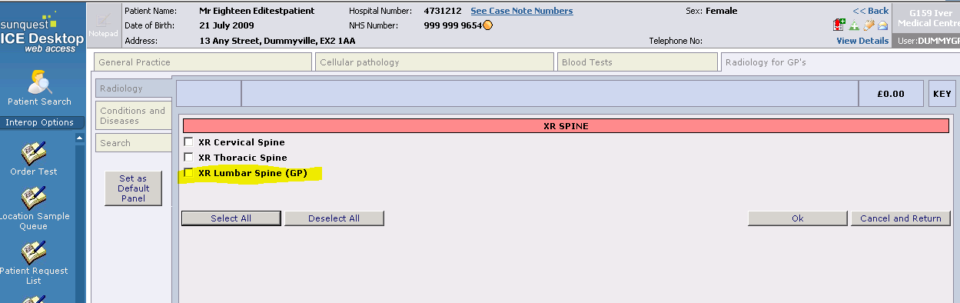
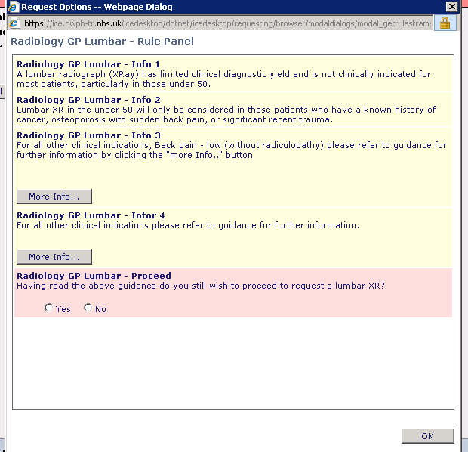
If patient under 50 is selected the following panel appears:
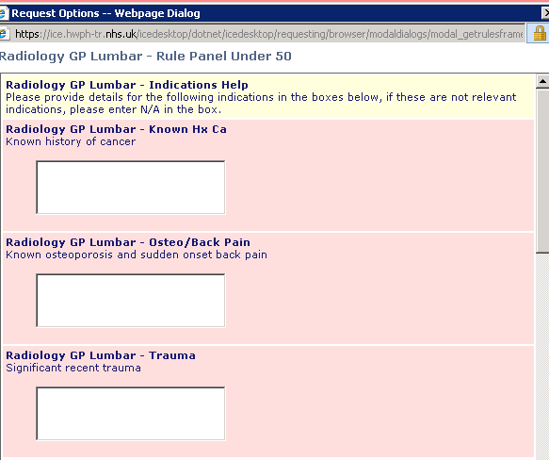
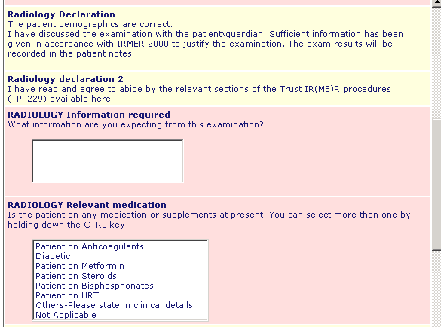
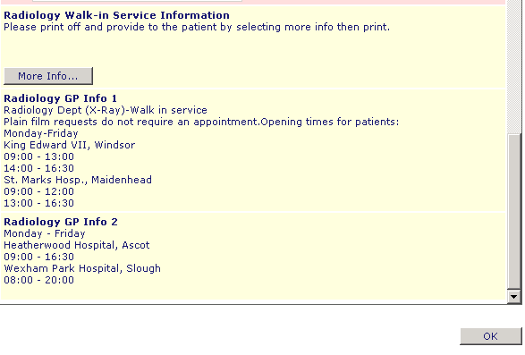
If patient 50 or over is selected the following panel appears
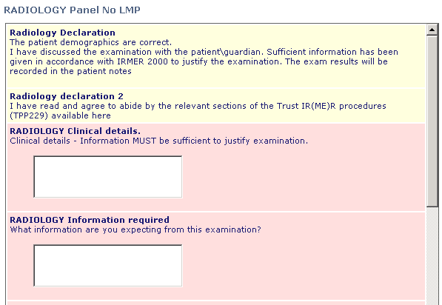
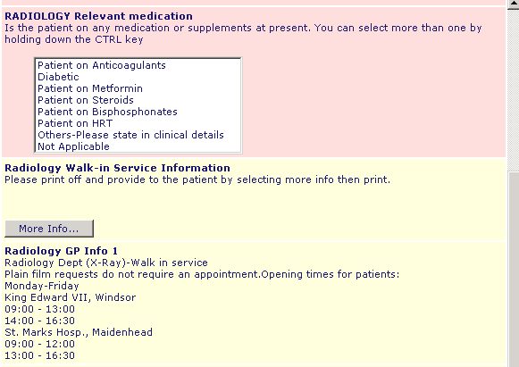

FPH radiology consultants hold a GP hotline phone daily to be able to discuss any cases and could decide no or alternative imaging may be more appropriate. I believe HWP has an email advice service.

