Clinical Guideline: Dermatochalasis & Ptosis of Eyelid Site: FPH

History
General Information

Examination
- Ptosis
- Check pupil reactions and eye movements
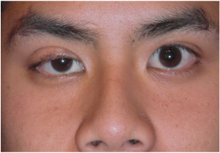

Advice and Treatment
Consider referral if:
- Acute or subacute ptosis may indicate significant neurological pathology and needs referral.
- Chronic isolated ptosis or dermatochalsis: refer if there is evidence of impairment of visual fields.

Referral Guidelines – red flag signs

Investigation

